**Audit Tools for TY programmes**

**Reflecting on our Curriculum**

This editable resource is part of a suite of three resources for reflecting on and renewing your school’s TY programme

# Reflecting on our Curriculum

There are four Curriculum Dimensions in the revised TY Programme Statement (2024). They are: Components, Teaching and assessment, Recognising and reporting, and Reflection and renewal.

The purpose of this resource is to support your school in reflecting on how your school’s TY curriculum supports the learning and development of the TY student. There are four Student Dimensions intended to guide the student and the school in the learning and development of the student during TY. The four Student Dimensions are: Personal Growth, Being a Learner, Civic and Community Engagement, and Career Exploration.

‘An effective TY programme, which will be unique to each school, is one where every aspect of the curriculum serves to develop the student in harmony with the Student Dimensions.’ (TY Programme Statement, 2024)

The four tables in this resource use the developmental indicators from the four Student Dimensions as the lens for reflection. These indicators are in the central column of each table.

There are two columns containing the Curriculum Dimensions that invite you to reflect back on your current TY curriculum and **reflect forward** on how you could renew your TY programme.

## Graphical overview of the TY Programme Statement

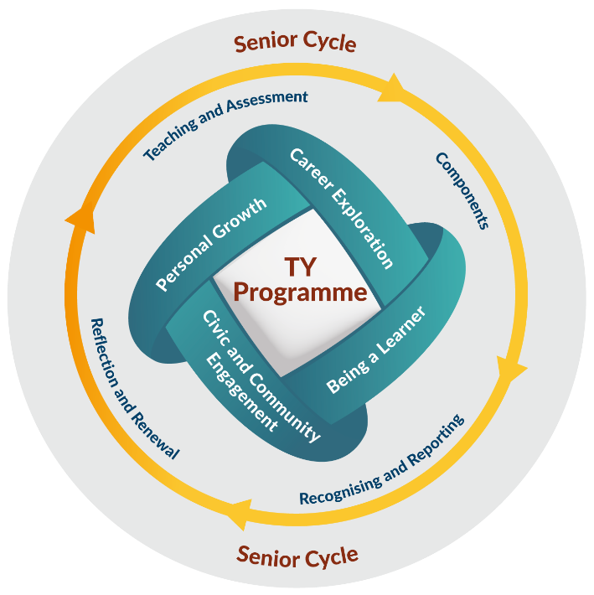

|  |  |  |  |  |  |  |  |  |  |  |  |
| --- | --- | --- | --- | --- | --- | --- | --- | --- | --- | --- | --- |
| **Reflecting on our curriculum through Personal Growth** | | | | | | | | | | | |
|  | | | | | | | | | | | | |
| 1. **Reflect back** on our current TY curriculum by:  * Identifying each aspect of the current TY curriculum that supports the Student Dimension * Underline any aspect of the curriculum not working well, needs to be reviewed, or replaced to allow for alignment with the 2024 TY Programme Statement, including developmental indicators. | | | | | **Personal Growth**  Students mature socially and emotionally over the course of the year, developing in areas that include health and wellbeing, autonomy, identity, empathy and leadership. | | 1. **Reflect forward** to our renewed TY curriculum by:  * Building upon the current TY curriculum * Highlighting below aspects of the current curriculum to be removed or to be reviewed for improvement * Including any new aspects of the curriculum to better support Student Dimensions and align better with the TY Programme Statement | | | | |
| **Curriculum Dimensions** | | | | | **Curriculum Dimensions** | | | | |
| **Components** | **Teaching and Assessment** | **Recognising and Reporting** | **Reflection and Renewal** | **Developmental indicators**  Becoming more assured and confident about themselves as a person.  Taking greater care of the health and wellbeing of themselves and others.  Setting and reviewing goals for personal development and achievement.  Having greater capacity to negotiate ethical dilemmas and reflect on personal values.  Knowing how to make more informed decisions.  Persevering longer with tasks, especially when challenging.  Coming to see challenges as further opportunities for growth.  Adapting better to groups and new social environments.  Interacting with others with more empathy, both in person and online.  Increasingly taking ownership of their own behaviours and decisions.  Showing more initiative and leadership in school, at home and in the community. | | **Components** | | **Teaching and Assessment** | **Recognising and Reporting** | **Reflection and Renewal** |
|  |  |  |  |  | |  |  |  |
|  | | | | | | | | | | | | |

|  |  |  |  |  |  |  |  |  |  |  |
| --- | --- | --- | --- | --- | --- | --- | --- | --- | --- | --- |
| **Reflecting on our curriculum through Being a Learner** | | | | | | | | | | |
|  | | | | | | | | | | | |
| 1. **Reflect back** on our current TY curriculum by:  * Identifying each aspect of the current TY curriculum that supports the Student Dimension * Underline any aspect of the curriculum not working well, needs to be reviewed, or replaced to allow for alignment with the 2024 TY Programme Statement, including developmental indicators. | | | | | **Being a Learner**  Building on their previous experiences, students begin to develop as senior cycle students, embracing opportunities and strategies for learning that work best for the student now and into the future. | 1. **Reflect forward** to our renewed TY curriculum by:  * Building upon the current TY curriculum * Highlighting below aspects of the current curriculum to be removed or to be reviewed for improvement * Including any new aspects of the curriculum to better support Student Dimensions and align better with the TY Programme Statement | | | |
| **Curriculum Dimensions** | | | | | **Curriculum Dimensions** | | | |
| **Components** | **Teaching and Assessment** | **Recognising and Reporting** | **Reflection and Renewal** | **Developmental indicators**  Being more motivated to learn and seeing education as worthwhile and enjoyable.  Setting learning goals and reviewing them regularly.  Becoming more skilled with digital technologies, both as a user and a creator.  Exploring their own personal interests.  Having a greater appreciation of lifelong learning.  Being more willing to learn from mistakes and expand their comfort zone.  Acquiring more knowledge and skills relevant to senior cycle.  Seeing the importance of feedback and placing more value on it.  Increasing their capacity for independent and self-regulated learning.  Being more open to trying a range of learning strategies.  Broadening their communication and presentation skills.  Expressing their own ideas more clearly while engaging with other people’s ideas. | | **Components** | **Teaching and Assessment** | **Recognising and Reporting** | **Reflection and Renewal** |
|  |  |  |  |  |  |  |  |
|  | | | | | | | | | | | |

|  |  |  |  |  |  |  |  |  |  |  |  |
| --- | --- | --- | --- | --- | --- | --- | --- | --- | --- | --- | --- |
| **Reflecting on our curriculum through Civic and Community Engagement** | | | | | | | | | | | |
|  | | | | | | | | | | | | |
| 1. **Reflect back** on our current TY curriculum by:  * Identifying each aspect of the current TY curriculum that supports the Student Dimension * Underline any aspect of the curriculum not working well, needs to be reviewed, or replaced to allow for alignment with the 2024 TY Programme Statement, including developmental indicators. | | | | | **Civic and Community Engagement**  Students make a positive difference  in their schools, communities and society. They learn to act on their responsibilities and exercise their rights as local, national and global citizens in ethical and  sustainable ways. | | 1. **Reflect forward** to our renewed TY curriculum by:  * Building upon the current TY curriculum * Highlighting below aspects of the current curriculum to be removed or to be reviewed for improvement * Including any new aspects of the curriculum to better support Student Dimensions and align better with the TY Programme Statement | | | | |
| **Curriculum Dimensions** | | | | | **Curriculum Dimensions** | | | | |
| **Components** | **Teaching and Assessment** | **Recognising and Reporting** | **Reflection and Renewal** | **Developmental indicators**  Sustaining more caring and respectful relationships with people, place and nature.  Having a greater appreciation and respect for human dignity and diversity.  Deepening their sense of empathy, identity and belonging.  Recognising and engaging with complexity and uncertainty.  Taking actions to live more sustainably.  Showing more initiative in their schools, communities, and society.  Setting and reviewing goals for being an active citizen.  Working more co-operatively with others and in teams.  Becoming more involved with creative and cultural activities.  Wanting to contribute to a more just world.  Understanding better the interconnections of local, national and global communities. | | **Components** | | **Teaching and Assessment** | **Recognising and Reporting** | **Reflection and Renewal** |
|  |  |  |  |  | |  |  |  |
|  | | | | | | | | | | | | |

|  |  |  |  |  |  |  |  |  |  |  |  |
| --- | --- | --- | --- | --- | --- | --- | --- | --- | --- | --- | --- |
| **Reflecting on our curriculum through Career Exploration** | | | | | | | | | | | |
|  | | | | | | | | | | | | |
| 1. **Reflect back** on our current TY curriculum by:  * Identifying each aspect of the current TY curriculum that supports the Student Dimension * Underline any aspect of the curriculum not working well, needs to be reviewed, or replaced to allow for alignment with the 2024 TY Programme Statement, including developmental indicators. | | | | | **Career Exploration**  Students explore diverse future pathways in a guided and coordinated manner, gaining first-hand workplace experience, and developing career-related competencies. | | 1. **Reflect forward** to our renewed TY curriculum by:  * Building upon the current TY curriculum * Highlighting below aspects of the current curriculum to be removed or to be reviewed for improvement * Including any new aspects of the curriculum to better support Student Dimensions and align better with the TY Programme Statement | | | | |
| **Curriculum Dimensions** | | | | | **Curriculum Dimensions** | | | | |
| **Components** | **Teaching and Assessment** | **Recognising and Reporting** | **Reflection and Renewal** | **Developmental indicators**  Being more informed on the links between education and career opportunities.  Increasing their awareness of personal interests, aptitudes, values and dispositions.  Identifying and reviewing career-related goals more regularly.  Having a greater capacity to research and critically reflect upon career pathways.  Acquiring more vocational, organisational and communication skills.  Learning how to generate ideas and turn ideas into action.  Improving their workplace knowledge and behaviours through first-hand experience.  Having more awareness of the world of work and enterprise. | | **Components** | | **Teaching and Assessment** | **Recognising and Reporting** | **Reflection and Renewal** |
|  |  |  |  |  | |  |  |  |
|  | | | | | | | | | | | | |