Audit Tools for TY programmes

**Reflecting on Student Experiences**

This editable resource is part of a suite of three resources for reflecting on and renewing your school’s TY programme

# Reflecting on our Student Experiences

There are four Curriculum Dimensions in the revised TY Programme Statement (2024), one of which is Components. The purpose of this resource is to support your school in reflecting on how the components of your school’s TY programme can be more aligned to the student experiences of each Student Dimension.

There are four Student Dimensions intended to guide the student and the school in the learning and development of the student during TY. The four Student Dimensions are: Personal Growth, Being a Learner, Civic and Community Engagement, and Career Exploration.

The four tables in this resource take each student experience from the four Student Dimensions. These student experiences are in the central column. The left-hand column then invites you to reflect back on the student experiences in relation to your current TY programme, based on the school’s evaluation of the components within the current TY programme. The right-hand column then reflects forward to how a renewed TY programme can support students more effectively across the student experiences. This may involve, for example, retaining a component, removing a current component from the programme, modifying an existing approach or adding in a new component to give a better opportunity for the student to develop in line with the developmental indicators.

‘An effective TY programme, which will be unique to each school, is one where every aspect of the curriculum serves to develop the student in harmony with the Student Dimensions.’ (TY Programme Statement, 2024)

The tables of student experiences are not intended to be exhaustive but to offer guidance to schools in their planning and in laying the foundations for their TY programme. While the developmental indicators set out the parameters for learning and development, students will develop in different ways and to varying degrees across each of the indicators. In this sense they also serve as reflective guidance for students. (TY Programme Statement, 2024)

## Graphical overview of the TY Programme Statement

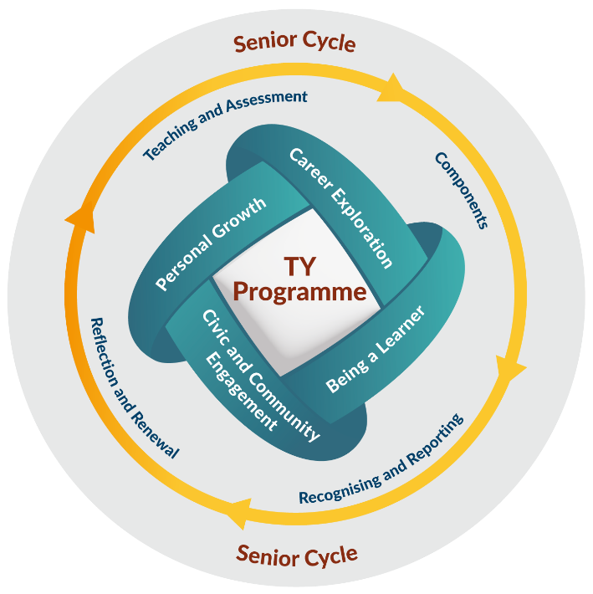

|  |  |  |  |  |  |
| --- | --- | --- | --- | --- | --- |
| **Personal Growth: Reflecting on Student Experiences** | | | | | |
|  | | | | | | |
| 1. **Reflect back** on our current TY programme:  * Is there a relevant component? * what is working well and not so well | | **Personal Growth**  Student Experiences | | 1. **Reflect forward** to our renewed TY programme:  * how to build on successes * learn from shortcomings that emerge from the backward reflection | |
|  | Collaborative projects, competitions, activities over the year to achieve collective goals. | |  | |
|  | Individual tasks and projects, involving digital and non-digital skills to enable self-expression. | |  | |
|  | Guided creation of a portfolio that captures their personal growth. | |  | |
|  | Education and guidance in personal and emotional development and social awareness. | |  | |
|  | Activities and experiences promoting lifelong physical and emotional health. | |  | |
|  | Opportunities for guided reflection and review of personal goals. | |  | |
|  | Formal and informal opportunities to speak and present in class, in public and in interviews. | |  | |
|  | Recognition of personal growth and personal challenges in all aspects of school life during the year. | |  | |
|  | | | | | | |

|  |  |  |  |  |  |
| --- | --- | --- | --- | --- | --- |
| **Being a Learner: Reflecting on Student Experiences** | | | | | |
|  | | | | | | |
| 1. **Reflect back** on our current TY programme:  * Is there a relevant component? * what is working well and not so well | | **Being a Learner**  Student Experiences | | 1. **Reflect forward** to our renewed TY programme:  * how to build on successes * learn from shortcomings that emerge from the backward reflection | |
|  | * Continuity subjects and sampling of subjects with learning designed to develop senior cycle key competencies. | |  | |
|  | * A variety of pedagogies consistent with realising the aims of the Programme Statement and supporting developmental indicators for all students. | |  | |
|  | * Meaningful learning opportunities that incorporate student input. | |  | |
|  | * Opportunities to build on student learning in the transition from junior to senior cycle. | |  | |
|  | * Assessment of their learning and development through a variety of forms such as teacher, peer and self-assessment, for formative and summative purposes. | |  | |
|  | * Recognition of achievement across all areas of the curriculum. | |  | |
|  | * Guided creation of a portfolio that captures the student, and their progress as a learner. | |  | |
|  | * A range of individual and team projects, competitions, activities over the year that are manageable and appropriately challenging. | |  | |
|  | | | | | | |

|  |  |  |  |  |  |
| --- | --- | --- | --- | --- | --- |
| **Civic and Community Engagement: Reflecting on Student Experiences** | | | | | |
|  | | | | | | |
| 1. **Reflect back** on our current TY programme:  * Is there a relevant component? * what is working well and not so well | | **Civic and Community Engagement**  Student Experiences | | 1. **Reflect forward** to our renewed TY programme:  * how to build on successes * learn from shortcomings that emerge from the backward reflection | |
|  | * Working with local or national organisations and businesses over the year. | |  | |
|  | * Opportunities to volunteer through community work and social placement. | |  | |
|  | * Education on sustainable development, including a meaningful action for a more sustainable world. | |  | |
|  | * Sharing of knowledge and skills within the school community and among community stakeholders. | |  | |
|  | * Guided creation of a portfolio that captures their civic and community engagement. | |  | |
|  | * Projects, competitions, activities in the classroom, in school, at home, in local communities and in society. | |  | |
|  | * Meaningful involvement with shaping school culture. | |  | |
|  | * Learning opportunities around empathy, diversity and inclusion. | |  | |
|  | | | | | | |

|  |  |  |  |  |  |
| --- | --- | --- | --- | --- | --- |
| **Career Exploration: Reflecting on Student Experiences** | | | | | |
|  | | | | | | |
| 1. **Reflect back** on our current TY programme:  * Is there a relevant component? * what is working well and not so well | | **Career Exploration**  Student Experiences | | 1. **Reflect forward** to our renewed TY programme:  * how to build on successes * learn from shortcomings that emerge from the backward reflection | |
|  | * Work placements during the year. | |  | |
|  | * Guided reflective tasks on their experiences and placements in TY. | |  | |
|  | * Subjects and modules on the senior cycle curriculum that link to future pathways. | |  | |
|  | * Career guidance and classroom support on future pathways. | |  | |
|  | * Guided creation of a portfolio capturing their reflections on career exploration. | |  | |
|  | * A variety of learning opportunities that improve practical and vocational skills. | |  | |
|  | * Access to career-related events or learning environments. | |  | |
|  | * Guest speakers from a diversity of backgrounds and careers. | |  | |
|  | * Short, certified courses or micro-credentials. | |  | |
|  | | | | | | |