

# Leaving Certificate Politics and Society

## Guidelines and sample questions for the written examination

#### August 2017

**NOTE**

The sample questions set out in this document were produced by the NCCA to support teaching and learning in the subject Politics and Society and prepare students for assessment in this subject.

The State Examinations Commission (SEC) will issue a sample examination paper at Ordinary and at Higher level during the first term of Year 2 of the course.

## The written examination

There are two assessment components for Politics and Society:

1. Report on a citizenship project, which is allocated 20% of the total marks
2. Written examination, which is two and a half hours long and is allocated 80% of the total marks.

The Leaving Certificate Politics and Society specification states the following:

*The written examination will examine:*

* *knowledge and understanding*
* *analysis and interpretation of qualitative and/or quantitative social and political data*
* *capacity to form reasonable and logical argument—clarity and coherence in argument and management of ideas.*

The examination paper is composed of three sections:

**Section 1**: **Short answer questions**

Short answer questions cover the topics of power and decision-making, active citizenship, human rights and responsibilities and globalisation and localisation.

**Section 2: Short answer and extended response questions on a data-based case study**

These questions will be based on unseen material and cover the skills of the retrieval, understanding and manipulation of data, thinking critically and independently; of analysing and interpreting qualitative and quantitative social and political research data; and of using such data carefully in coming to conclusions. Candidates being assessed at Higher Level will also be assessed on their capacity to draw more broadly on their wider knowledge from the study of Politics and Society of power and decision-making, active citizenship, human rights and responsibilities and globalisation and localisation.

**Section 3: Discursive essays**

These questions will require candidates to write extended discursive responses on the topics of power and decision-making, active citizenship, human rights and responsibilities and globalisation and localisation. In their responses to the questions or stimuli provided in this section candidates will be expected to draw on their knowledge and understanding across the relevant topics as well as demonstrate their skills in critical, discursive and independent thinking.

Format of the written examination

The written examination will take the form of a completion-type booklet produced by the State Examination Commission will:

* State the marks allocated for each section of the paper
* Advise on the time to be given to answering each question/section of the paper
* Provide students with spaces in which to write their responses and include ‘additional pages’ should candidates require them.

General assessment criteria for the written examination

A high level of achievement in the written examination is characterised by a thorough knowledge and understanding of facts, concepts, theories and methods from the whole specification and with few significant omissions. Candidates consistently apply their knowledge and understanding of Politics and Society to both familiar and new contexts. They accurately analyse and evaluate qualitative and quantitative data from different sources where appropriate; manipulation of data, where appropriate, will be almost flawless. Candidates present logical arguments and ideas which are clearly based on evidence.

A moderate level of achievement in the written examination is characterised by a good knowledge of facts, concepts, theories and methods from many parts of the specification. Candidates apply their knowledge and understanding of Politics and Society to familiar contexts and to some new contexts. They carry out reasonable levels of analysis and evaluation on qualitative and quantitative data from different sources where appropriate; much of their manipulation of data will be correct. Candidates present arguments and ideas which, in the main, are based on evidence.

A low level of achievement in the written examination is characterised by a limited knowledge and understanding of facts, concepts, theories and methods. Candidates select some appropriate facts, concepts and methods to apply to familiar contexts. They carry out basic manipulation of data correctly. Candidates present explanations which are referenced to some evidence, often from familiar contexts.

Differentiation

Differentiation at the point of assessment will be reflected in the structure of the examination paper and in the style of questioning. Consideration will be given to the language level in the examination questions, the level of demand of the stimulus material provided, the structure of the questions and the level of support provided for the examination candidates*.*

## Guidelines on the written paper

## 

**Higher Level Paper**

|  |  |  |  |
| --- | --- | --- | --- |
| **Question type** | **Number of questions to be attempted** | **Response format** | **Higher level**  **Weighting (marks)**  **Indicative time** |
| 1. Short answer questions | Students answer 10 questions out of 12 | Responses involving at most a few short sentences. | 10% (50 marks)  15-20 mins |
| 2. Short answer and extended response questions on data-based case study | This question is based on unseen research data provided.  There are a number of parts to this question and students answer all parts. | This question requires both short answer and extended responses. | 30% (150 marks)  50-55 mins |
| 3.Discursive essays | Two questions from a choice of four | Discursive responses | 40% (200 marks)  70-75 mins |
| TOTAL MARKS | | | 400 |

**Ordinary Level Paper**

|  |  |  |  |
| --- | --- | --- | --- |
| **Question type** | **Number of questions to be answered** | **Response**  **format** | **Weighting**  **Ordinary level** |
| 1. Short answer questions | Students attempt 15 questions out of 20 | Responses involving at most a few short sentences. | 20% (100 marks)  35-40 mins |
| 2. Short answer and extended  response questions on data-based case study | This question is based on research data provided  There are a number of parts to this question and students answer all parts. | The question requires mainly short answer response answers and some extended responses. | 30% (150 marks)  45 - 50 mins |
| 3.Discursive essays | Three questions from a choice of six | Discursive responses | 30% (150 marks)  55-60 mins |
| TOTAL MARKS | | | 400 |

Differentiation between ordinary and higher level

**Section 2: Questions on data-based case study**

In answering section 2, candidates at *ordinary level* will be expected to:

* identify and extract relevant information from the data provided
* draw inferences from the data
* evaluate the methodology used in addressing the research question
* identify whether a particular conclusion is justified based on the data provided
* make comparisons between different data sets
* answer a question that requires them to demonstrate their wider knowledge from Politics and Society

Candidates at *higher level* will be expected to:

* identify and extract relevant information from the data provided
* draw inferences from the data
* evaluate the methodology used in addressing the research question
* identify whether a particular conclusion is justified based on the data provided
* be able to make comparisons and draw conclusions based on a range of data sources and relate it to knowledge acquired as part of their wider study in Politics and Society
* draw on their knowledge of Politics and Society to critically discuss ideas within a wider context

**Section 3: Discursive essay questions**

This section of the examination will assess the candidate’s skills in critical, discursive and reflective thinking. It will also assess their ability to recall and use the knowledge, concepts, theories and broad data that they have learned through their studies in Politics and Society. Students taking the examination at higher level will be expected to demonstrate independent thinking in drawing their own evidence-based conclusions. They will also be expected to make comparisons and be able to apply ideas to both familiar and unfamiliar contexts. In addition, they may be asked to make use of learning from more than one topic/strand in responding to a question. Ordinary level candidates will present explanations and arguments, mostly from familiar contexts with limited comparative analysis. Questions at Ordinary Level will exhibit greater levels of scaffolding to provide these candidates with a better platform to demonstrate their achievement.

## Sample questions

These sample questions are intended to illustrate the type of questions that could be asked on the Politics and Society written examination paper.

### **Ordinary Level**

**Sample Short Questions**

1. Which of the following terms means supreme power?
2. Democracy
3. Sovereignty
4. Imperialism
5. Autonomy
6. Which of the following terms is used to describe a situation where people cooperate with the state and give up some of their freedom in return for certain benefits?
7. The social contract
8. Social justice
9. Socialism
10. Communism
11. State whether each of the following statements is TRUE or FALSE
12. The UN Committee on the Rights of the Child (CRC) is responsible for monitoring the progress states are making in implementing the United Nations Convention on the Rights of the Child (UNCRC).
    * + 1. Once governments sign up to a human rights Convention then they must make laws to guarantee the absolute right of all citizens to these human rights with immediate effect.
13. Briefly explain the purpose of Ireland’s social partnership process?
14. Look at this photo which shows refugees escaping a war zone.

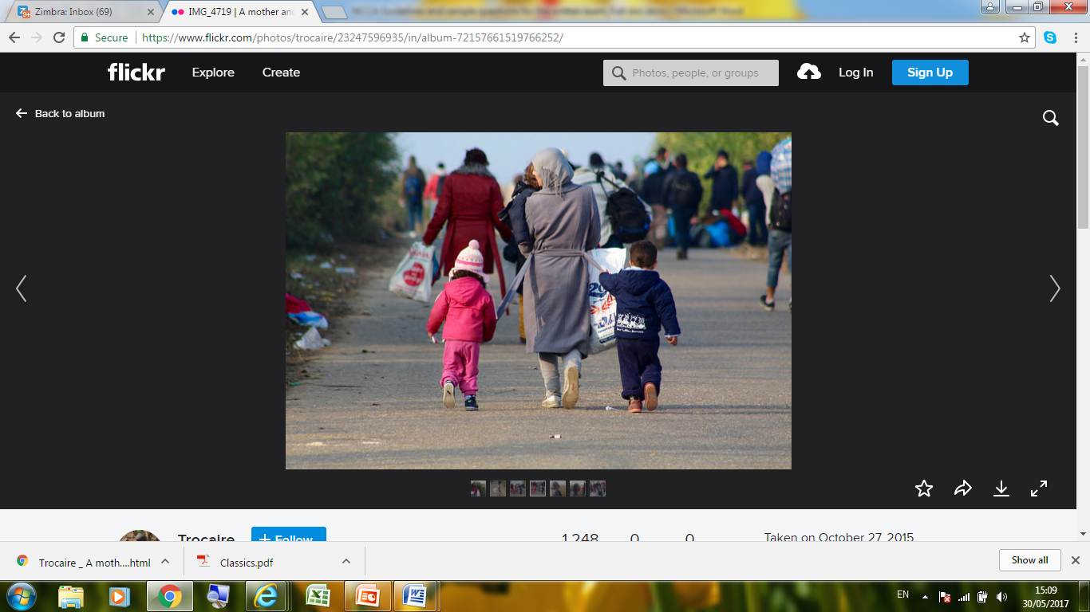

(Credit: www.trocaire.org)

Name one of the rights contained in the European Convention on Human Rights which these people are seeking to secure by leaving their homes.

* 1. The organization and running of the Irish state is divided into three branches of government. Which branch interprets the law?

1. The legislative power
2. The executive power
3. The judicial power
   1. Explain the terms ‘*positive right’* and ‘*negative right’*. Give an example of each of these rights.
   2. Which of the following statements properly expresses the meaning of patriarchy?
      1. unequal power relations between women and men which results in women having more power in society than men
4. a system of unequal power relations between women and men which works to systematically keep women disadvantaged and oppressed.
5. equal power relations between women and men where men and women have equal rights and responsibilities in society
6. ‘*Cultures are the product of a process of mixing and adaptation and do not stay static over time*.’ Give one example from your own environment which provides evidence of this.
7. Explain what is meant by ‘civil disobedience’. Describe one example of civil disobedience.
8. Give one example of how globalisation has had a positive impact upon women in less developed countries.
9. Describe two ways that people like this Kenyan farmer is being affected by climate change.

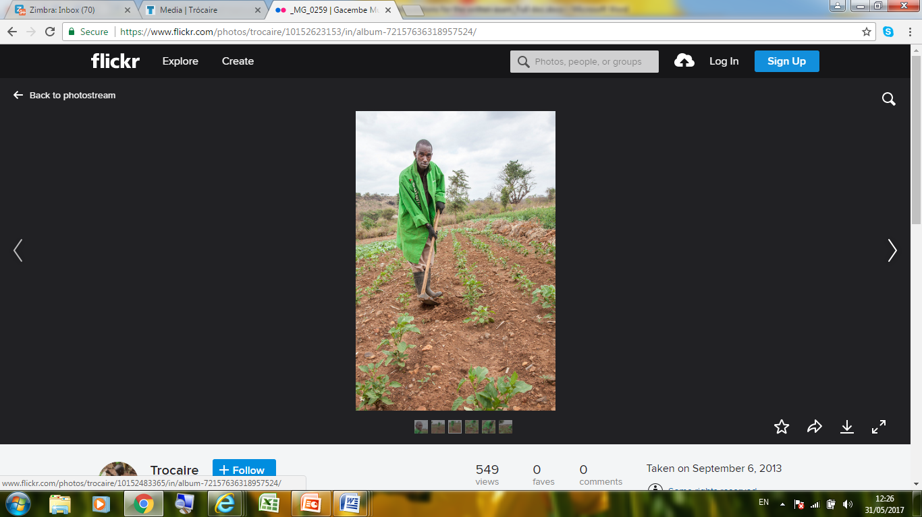

(Photo credit: [www.trocaire.org](http://www.trocaire.org))

### **Higher Level**

**Sample Short Questions**

1. Briefly, give one positive impact and one negative impact of economic globalisation.
2. States have an immediate obligation to guarantee some human rights while other rights can be achieved through progressive realization. Give one example of each of these types of rights.
3. The Northern Ireland Executive is made up of the First Minister, deputy First Minister, two Junior Ministers and eight departmental ministers. Name one strength and one weakness of the system that enables the Northern Ireland Executive to be selected.
4. Using mobile technology ordinary people can play an active role in the process of collecting, reporting, analysing, and disseminating news and information. This is sometimes called ‘citizen journalism’. Give one advantage and one disadvantage of this for democratic societies.
5. Give an example of how social class is a factor in reinforcing inequality in the Irish education system.
6. Explain what is meant by ‘the social contract’, giving an example of how it operates in school **or** society.
7. [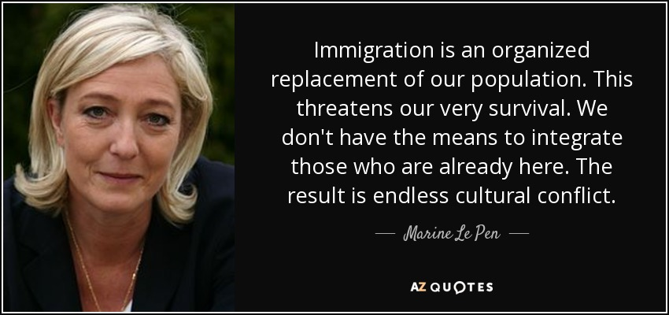](http://www.azquotes.com/quote/709092)Read the quote from French politician, Marine Le Pen (National Front party), and name a political thinker from your studies you think she would most agree with and explain why.
8. 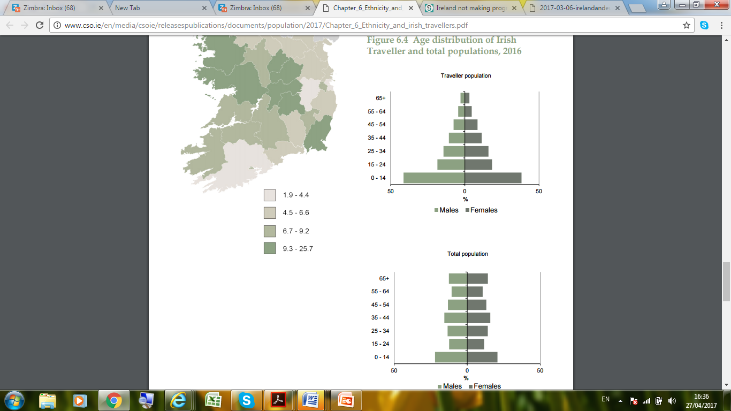

(Source: CSO 2016)

The table above shows the age distribution of Irish Travellers compared to the general

population.

What, in your opinion, is the main difference that this table shows? Give one possible reason for this.

1. Briefly describe the role of the International Monetary Fund (IMF) **or** the World Bank.
2. Outline two qualities that are associated with bringing about effective social action.
3. Name a political thinker you have studied who would be associated with the **view** expressed below. Justify your answer.

*The west has historically constructed itself (‘us’) in opposition to the non-western world (‘them’) and, in doing so has imagined itself to be rational, civilised and mature and has imagined the non-western world as irrational, depraved and child-like.*

1. Explain how this photo provides evidence of the unequal impact of climate change on people in less developed countries?



(Photo taken in Turkana, Kenya by David O’Hare

Photo credit: [www.trocaire.org](http://www.trocaire.org))

**Ordinary Level**

**Data-based sample question 1**

Study documents A and B and then answer the questions below.

**Document A**

The table below is taken from the website of the Central Statistics Office (Ireland) and relates to a research report called ‘Women and Men in Ireland 2013’. The table shows membership of some branches of government and decision making in Ireland according to gender*.*

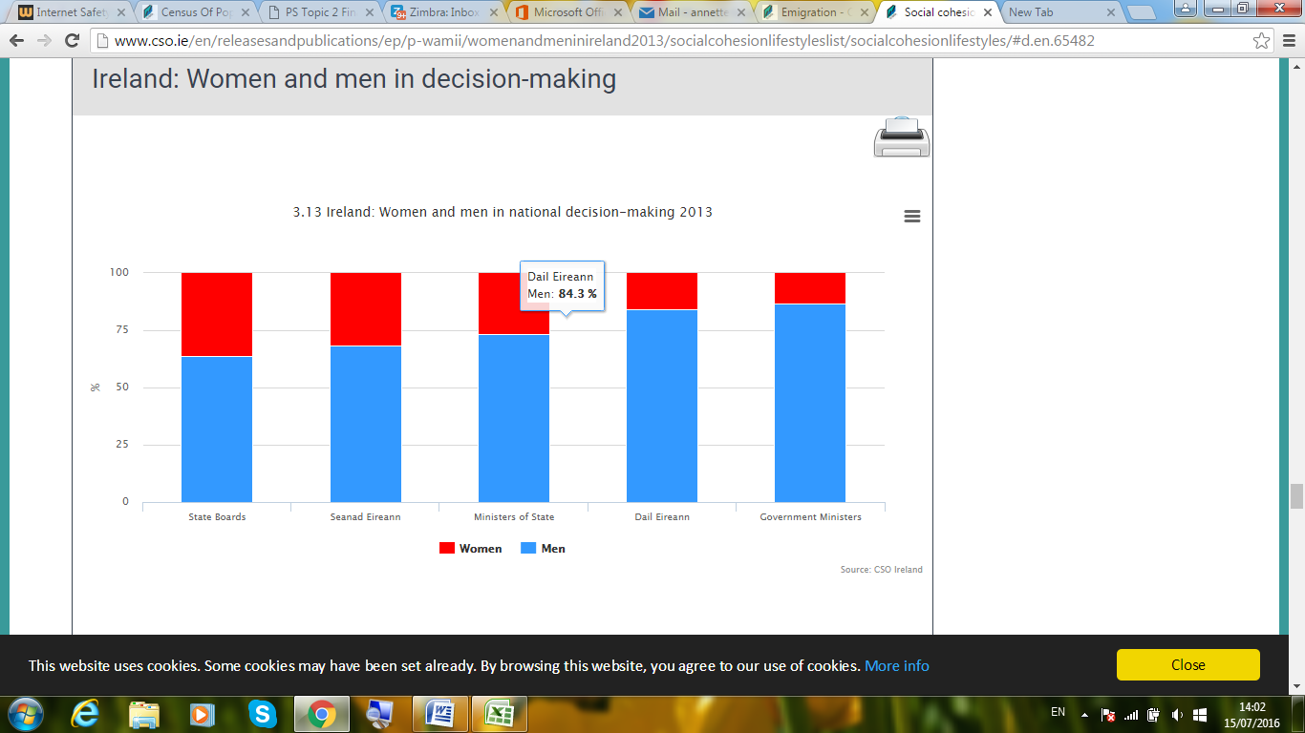

Accessed at: <http://www.cso.ie/en/releasesandpublications/ep/p-wamii/womenandmeninireland2013/socialcohesionlifestyleslist/socialcohesionlifestyles/>

**Document B**

The following is an edited excerpt from a report called ‘Women in Public Life’, which was prepared for a meeting of the North-South Inter-Parliamentary Association in 2015. This excerpt explores some research relating to reasons why women are less likely to gain higher positions in employment.

***Women in Public Life***

Two aspects of caring duty in particular in Ireland and Northern Ireland make it a potential barrier to women seeking election or appointment to positions of seniority ….

First, survey research for Ireland has found that women are responsible for more than 80% of the tasks of family life e.g. childcare, taking care of elderly parents, cooking.

Second, professional childcare services in Ireland are the most expensive in Europe and the second most expensive in the OECD[1] and Northern Ireland is the most expensive region in the UK for accessing childcare and the lack of affordable childcare is seen as an impediment (obstacle) to women’s participation. A report by Indecon (2013) found that the cost of childcare in Ireland, as a percentage of average wages, is second highest in the OECD. The European Anti-Poverty Network (EAPN Ireland) estimates that childcare costs account for 51% of total costs or 30% of disposable income in double income households with two young children.

In fact, a recent research report seeking to explain why 79% of chief executives in the public sector in Northern Ireland are men, found that:

* Women were more likely to opt out of career progression than men;
* The two most common reasons for opting out were caring for dependent children and long hours culture;
* Among the barriers to progression as an individual, female respondents saw caring responsibilities and lack of awareness of organisational politics as barriers whilst males did not;
* Among the organisational barriers to progression, female respondents saw colleagues’ negative reactions to flexible work arrangements, lack of recognition for work life balance, exclusion from informal networks, lack of opportunities to work on challenging assignments and long hours culture as barriers whilst males did not.

Accessed at: <https://www.oireachtas.ie/parliament/media/housesoftheoireachtas/libraryresearch/others/20151112_NSIPAWomeninpubliclife.pdf>

**Questions:**

**Part 1**

1. According to document A, which category of government and decision-making has the least number of women members?
2. According to document A, what percentage of members of Dáil Eireann are women?
3. Is the data in document B trustworthy? Justify your answer.
4. According to document B, what are the main reasons that make it difficult for women to be appointed to senior positions in Ireland and Northern Ireland?
5. How does the research summarised in document B help to explain the data in document A?

**Part 2**

1. Suggest one policy change that would increase the number of women elected to political institutions in Ireland. Explain what you think the impact of such a change would be.
2. Do you agree or disagree with the view that modern Irish society is a patriarchy? Explain your answer. You may use the data provided here to back up your answer. Your answer should also refer to your learning in Politics and Society.

**Higher Level**

**Data-based Sample Question 1**

Study documents A and B and then answer the questions below.

**Document A**

On 18th September 2014, a referendum was held on whether Scotland should or should not become independent from the rest of the United Kingdom. The proposal that Scotland should be independent was defeated. This was the first time that voters aged 16 to 18 years could vote in Scotland. Following the referendum, a sample of 1,852 voters and non-voters were interviewed so that their behaviour, attitudes and motivations towards the referendum could be understood.

The table below is an excerpt from a report based on the research. This table focuses on how voters from various age categories viewed the decision to lower the voting age in the referendum to 16 years.

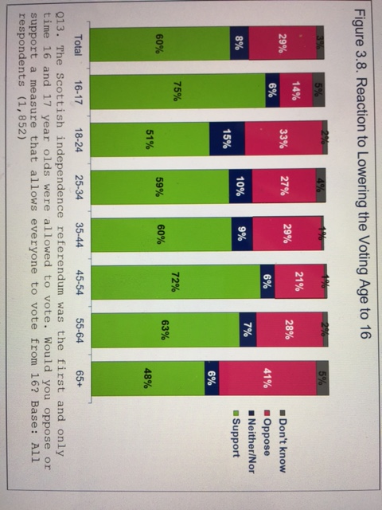

**Source:** *Scottish Independence Referendum Research: Post-Polling Day Opinion Research Repor*t. Prepared by ICM Research on behalf of The Electoral Commission (November 2014). Accessed at <http://www.electoralcommission.org.uk/__data/assets/pdf_file/0005/179807/Scottish-referendum-Public-Opinion-survey-ICM-Report-WEBSITE.pdf>

**Document B**

The following extract is from a report based on data from a survey of over 7,400 adults (carried out in February 2015, after the Scottish referendum), as well as a representative survey of 800 16-17 year olds (carried out with half in Scotland and half in the rest of the UK). The survey examined whether long-term changes can be seen in Scotland following the reduction of the voting age in the referendum. The data allows for a comparison of young people in these age groups in Scotland and the rest of the UK. The author draws conclusions based on the research findings.

The referendum was a special occasion and several commentators have voiced doubts whether the positive effects would last much beyond the [referendum] vote on 18 September and in particular would hold for the context of a general election. Our research now shows that indeed, we find a continuation of the positive effects – and particularly strongly pronounced for the youngest age groups.

Voting likelihood proves to be higher in all age groups in Scotland, with 76% saying they were certain to vote in February [in the General Election] compared to other parts of the UK (on average 65%). However, the difference is distinctively most pronounced for younger age groups. While 63% of 18-19 year olds in Scotland say they were certain to vote in the General Election, only 27% of their English peers say the same. In no other age group is the gap as substantial, suggesting that in particular the youngest age group (who were 16-17 at some point during the two-year referendum campaign) saw a substantial change, implying that there may be more than a general referendum effect.

Most crucially, all measures of increased political engagement have outlasted the referendum itself and apply to the general election context, even for the 16-17 year olds in Scotland. Comparing them with their English counterparts we found that 61% say they had talked about “how the UK is governed” with members of their family in the last three months (roughly mid-November to mid-February at the time of the survey), while only 37% of their English peers report the same. The higher level of engagement with political issues applies not just to concerns about Scottish independence, but UK politics more widely. The gap is even more pronounced when asked whether the 16-17 year old respondents had talked with their friends about this in the same time period, with 62% of Scottish respondents answering positively compared to only 35% in England.

These findings are consistent with research from one of the few countries that has implemented voting at 16 at all elections in 2007 – Austria. Studies have shown an initial boost amongst the newly enfranchised voters in terms of positive political and civic attitudes and voting participation, but also, most crucially, a sustained nature of this effect in the longer run.

**Source:** Submission from Dr Jan Eichhorn, University of Edinburgh, to Scottish Parliament regarding Scottish Elections (Reduction of Voting Age Bill) 2015. Accessed at [http://www.parliament.scot/S4_ScotlandBillCommittee/General Documents/Jan_Eichhorn.pdf](http://www.parliament.scot/S4_ScotlandBillCommittee/General%20Documents/Jan_Eichhorn.pdf)

**Questions:**

**Part 1**

1. In document A, which age cohort shows least support for extending the vote to 16 and 17 year olds? Suggest a reason for this?
2. How does the research data in document B show an increased level of political engagement by young Scottish voters compared to young English voters?

**Part 2**

1. From your examination of document A, do you find any aspect of the data surprising? Explain your answer.
2. The data in document A is presented by the Electoral Commission, the independent body which oversees elections and regulates political finance in the UK. Is it important to be aware of the source of data such as this? Explain your view, using this piece of data as an example.
3. In document B, why do you think that some commentators expressed doubts that the positive effects of extending the vote to 16 and 17 year olds would last beyond the referendum?

**Part 3**

**Candidates are expected to write 2-3 extended paragraphs in response to either**

**a. or b. below.**

1. Drawing on both sets of data in Document A and Document B, and on your wider learning in Politics and Society, briefly set out the case you would put to the Irish government arguing for or against extending the right to vote to 16 and 17 year olds in Ireland.

**OR**

1. Apart from young people, what other group or groups in society are under-represented in political decision-making? What is the impact of this? Support your answer with evidence from Ireland or the wider world.

**Data-based sample question 2**

**Ordinary Level**

**Document A - Young people’s leisure activities in Ireland**

Dr Áine De Róiste and Joan Dineen from Cork Institute of Technology (2005) conducted a written survey with a random sample of 2,260 young people aged 12 – 18 from across the country asking them what sports they participate in. Their answers are in the table below.



The same survey asked them about the barriers to their recreation. Their answer to one of these questions is below.



***Document B - Young people’s leisure in Tasmania, Australia***

In 1998-99 Joan Abbott-Chapman and Margaret Robertson from the University of Tasmania in Australia surveyed and interviewed people on the Australian island of Tasmania aged about 14-15 years old about their local space and their leisure. They gathered 256 completed questionnaires and 58 interviews (28 girls, 30 boys). Their survey was broadly representative of Tasmania in general except that children of working class or unemployed families were over-represented. For the interviews they showed people pictures as a way of prompting them to talk about their favourite places.

They found that when the young people in their study were asked about their favourite places they tended to emphasise quiet, personal spaces such as ‘home’, ‘my bedroom’ or ‘a beach’ or ‘a nearby river’. Girls were more likely than boys to focus on quiet spaces.

The authors claim that in the modern world in which the media bombards young people with images and ideas from around the world, young people desire time and space in their own neighbourhood to develop their own sense of identity. They note that, despite the media focus on young people’s loud behaviour in towns or built up areas, their ideal spaces are often quiet. For many, they are ‘natural’ spaces, like rivers, beaches or out in the wild countryside. They write:

*“The results confirm the picture …of a group of young adolescents who are very home and neighbourhood-centred in their leisure activities. 'Hanging out' with friends, being involved in social activities with friends, or playing sports in the local neighbourhood close to home (and not in the nearest town centre)…The students' activities are therefore extremely local.’’*

# (From the article ‘Youth, Leisure and Home: Space, Place and Identity’, published in the journal *Society and Leisure*, 2001 [Vol. 24; No. 2])

**Sample Questions for Ordinary Level**

**Part 1**

1. From document A, what are the three most popular sports for boys and for girls?
2. From document A, what is the least popular sport for boys and for girls?
3. According to document B, where do young people in Tasmania like to spend their leisure time?

**Part 2**

1. What method was used to conduct each piece of research?
2. Based on the methods used, which piece of research would you think is stronger and more reliable? Explain why.

**Part 3**

1. According to Article 31 of the UN Convention on the Rights of the Child, *all children have the right to rest, leisure, play and recreation.*
2. Why is this right so important for children and young people everywhere?
3. From your studies, do you think the right to rest, leisure, play and recreation is well protected and promoted in Ireland? Give evidence to support your answer.

**Sample essay questions - Ordinary level**

1. Imagine you are appointed Principal of a new school and you can design how the school is organised and draw up the rules from scratch. What would you do?

Your answer should include:

* + 1. Why you think rules are needed or not needed
    2. How you would organise decision-making in the school

1. How does social class position influence the life chances of teenagers growing up in Ireland today? Your answer should discuss and provide examples of how social class influences a young person’s chances in relation to one or more of the following – education, health and/or employment.
2. How is diversity and cultural change evident in Ireland today and what are the reasons for it? Your answer should be supported by evidence from your studies.
3. Pick one or more of the following rights (outlined in the UN Convention on the Rights of the Child) and give evidence on the extent to which these rights are implemented around the world:

* The right to survival and development
* The right to freedom of thought, conscience and to have and manifest their religion or beliefs
* The right to protection from physical or mental violence, injury, neglect or abuse

1. Imagine you are writing to a political representative about an issue of discrimination in Ireland that concerns you. Set out your points of concern in a letter and be sure to back them up with evidence.

Note: Your letter should relate to one or more of the nine grounds under which discrimination is illegal in Irish law.

1. 'Rich countries should be paying the cost for climate change.' Examine this view supporting your answer with evidence from your studies.
2. Explain how the executive branch of government is formed in Ireland (either North or South) and compare this process with an example from a non-democratic country.
3. Describe how international co-operation has helped to support human rights. Your answer should refer to the role of one or more supranational bodies or organisations that support human rights.

**OR**

Describe the role of either the International Monetary Fund or the World Bank and explain how this supranational body impacts upon the lives of young people in Ireland or in another country you have studied.

**Sample essay questions - Higher level**

1. Does social class matter in Irish society and what are the consequences that flow from social class in terms of life chances?

Your answer should draw on at least one theorist you have studied and refer to relevant qualitative and/or quantitative research data.

1. How useful are the ideas of Thomas Hobbes **or** John Locke for organising the rules and workings of a school? Identify a modern political or social theorist that would most influence or inspire the way you would wish to organise your school and explain why.
2. A. Examine critically the view that the growth of digital news has created greater freedom of the press alongside less social responsibility of the press.

**OR**

B. Examine critically the positive and negative effects of the growth of digital media for democratic and non-democratic countries.

In both cases, your answer should be supported by examples/evidence.

1. **“***Education either functions as an instrument which is used to facilitate integration of the younger generation into the logic of the present system and bring about conformity, or it becomes the practice of freedom, the means by which men and women deal critically and creatively with reality, and discover how to participate in the transformation of their world.”* Paulo Freire

Looking at contemporary Ireland and/or another country, to what extent can Freire’s view be backed up by evidence? Your answer should refer to relevant research data.

1. What are the personal qualities and political strategies that are associated with being most effective when working to bring about social change? Discuss giving examples.
2. Discuss the implications of globalisation for any two of the following social processes and human experiences: work, migration, terrorism, poverty, the environment.

Your answer should draw on relevant theorists and/or research evidence.

1. "*The notion that aid can alleviate systemic poverty, and has done so, is a myth. Millions in Africa are poorer today because of aid; misery and poverty have not ended but increased. Aid has been, and continues to be, an unmitigated political, economic, and humanitarian disaster for most parts of the developing world.*’’

(Dambisa Moyo, writing in *Dead Aid: why aid is not working and how there is another way for Africa)*

Evaluate this view that rather than enabling development, Aid has increased poverty and underdevelopment. Your answer should also consider other theories put forward to explain underdevelopment and poverty in the world and come to a conclusion as to which view you consider most supportable, drawing on relevant theorists and/or research evidence.

1. Evaluate the argument that power is moving in modern times from national governments to supranational bodies.

**OR**

Looking at recent political events and elections, discuss the view that political parties fail to represent the will of the people.

In both cases, your answer should draw on examples from different contexts and on relevant theorists and/or research evidence.

1. The OECD is the Organisation for Economic Co-operation and Development, with 34 democratic countries making up its membership.