Reff

Audit Tools for TY programmes

**Components Overview Table**

This editable resource is part of a suite of three resources for reflecting on and renewing your school’s TY programme

# Components Overview Table

## Components is one of the four Curriculum Dimensions of the TY Programme Statement.

## The Components Overview Table below is based on *Table 3 Accommodation of components* in a TY curriculum in the TY Programme Statement.

## ‘Components are the means by which most of the student experiences, described in the Student Dimensions, are translated into the school’s TY curriculum.’ (TY Programme Statement, 2024)

## The left-hand column identifies the Student Dimension and the centre column outlines the types of components that make up a TY programme in line with the TY Programme Statement. The right-hand column of the Components Overview Table can be overwritten with the components that make up the TY programme you are examining as part of the reflection and renewal process. Typically this would be the components of your current TY programme and how they align to the types of components described in the TY Programme Statement.

## The Components Overview Table can be used in several ways in the general process of reflection and renewal. For example, as a summary table at the end of the reflection process to capture the components of a renewed TY programme, or to begin the reflection process and highlight where the TY programme could be renewed.

## Graphical overview of the TY Programme Statement

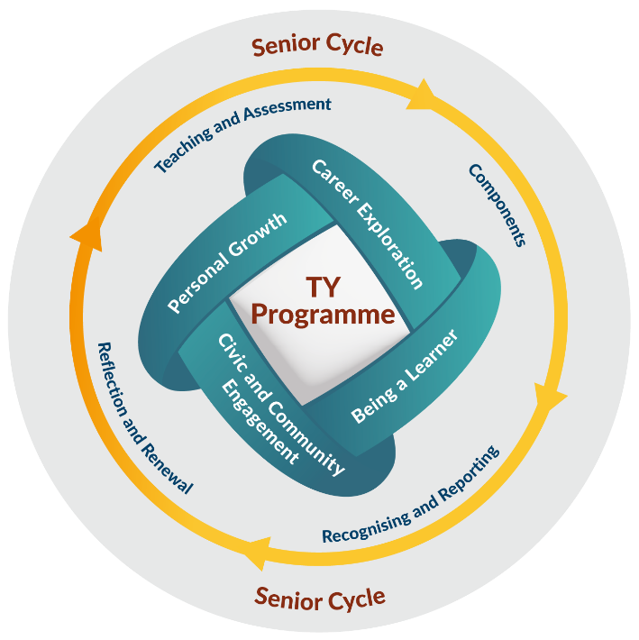

# Components Overview Table

##### Structure based on Table 3 of the revised 2024 TY Programme Statement. See the [exemplar on NCCA’s website](https://www.curriculumonline.ie/senior-cycle/transition-year/supports-for-the-ty-programme-statement/reflection-and-renewal-toolbox/).

##### The right-hand column is intended to show how our TY programme aligns to the TY Programme Statement.

|  |  |  |
| --- | --- | --- |
| Student Dimension | Types of Components | The components in our school – what we have and what we need |
| **Personal**  **Growth** | Continuity   * PE aligned of the PE Framework * SPHE (once per week) |  |
|  | TY specific   * An array of modules that provide experiences for the development and growth of the student |  |
|  | Additional growth experiences  For example: guest speakers, government supported  developmental awards, induction, competitions, school-wide events, such as plays, musicals, market days, and themed days. |  |
| **Being a Learner** | Continuity  Supporting student learning and development  (not exceeding 2 hours per week for Irish, English, Mathematics) |  |
|  | Elective  Modules that support sampling and other areas of learning and development  (equivalent of 3-4 hours per week, depending on school context) |  |
|  | Additional learning experiences  For example: study and research skills, themed learning days, life-skills, literacy-numeracy |  |
|  | Portfolio Development  Creating the TY Portfolio, self-assessment, student planning.  One class per week. |  |
| **Civic**  **And**  **Community**  **Engagement** | Our own community  Local out-reach activities, community placement, social enterprise activities, education in cultural diversity |  |
| Our global community   * Education for Sustainable Development * A meaningful student-led personal or collaborative action related to sustainable living |  |
| **Career Exploration** | Work Placement  Community Placement  (2–4 weeks equivalent) |  |
|  | Career guidance  One class per week or classes timed to target key events |  |
|  | Additional career-related experiences  For example: guest speakers, tasters in Apprenticeships / Traineeships / Further Education / Higher Education, information days, government supported developmental awards, certified short courses. |  |